ANNUAL FISHWAY
STATUS
REPORT

For

BONNEVILLE DAM

2002

By

Jennifer D. Sturgill
Tammy M. Mackey
Timothy J. Darland

U. S. Army Corps of Engineers
CENWP-OP-B
Bonneville Lock & Dam
Cascade Locks, OR 97014
(541) 374-8375

28 January 2002
TABLE OF CONTENTS

Introduction
2
FISHWAY oPERATION AND aCTIVITIES 3
FISH PASSAGE PLAN (FPP) VIOLATIONS 4
Auxiliary Water System (AWS) Closures 5
Fish UNIT Outages 5
Fish FACILITY Outages and Maintenance 5
TURBINE OUTAGES AND DEWATERINGS 6
fISH REMOVAL 6-7
VBS/STS INSPECTIONS
Table 1. Submersible Traveling Screen (STS)and Vertical Barrier Screen (VBS) Inspections 8
ZEBRA Mussels 8
GLOSSARY 9
REFERENCES 10

INTRODUCTION

This document summarizes activities impacting fish at Bonneville Lock & Dam from 1 December 2001 through 30 November 2002.

Primarily a summary of weekly reports, this document is required by the Corps of Engineers’ North Pacific Division, as described in the Fish Passage Plan (FPP) . The FPP contains the following surveillance and reporting requirements. “Project biologists shall inspect fish passage facilities at the frequencies listed in the juvenile and adult fish facilities operating criteria sections. The (weekly) reports shall include: any out of criteria situations observed and subsequent corrective actions taken; equipment malfunctions, breakdowns or damage, along with a summary of resulting repair activities; adult fish control calibrations; STS and VBS inspection; any unusual activities which occurred at the project which may affect fish passage.”

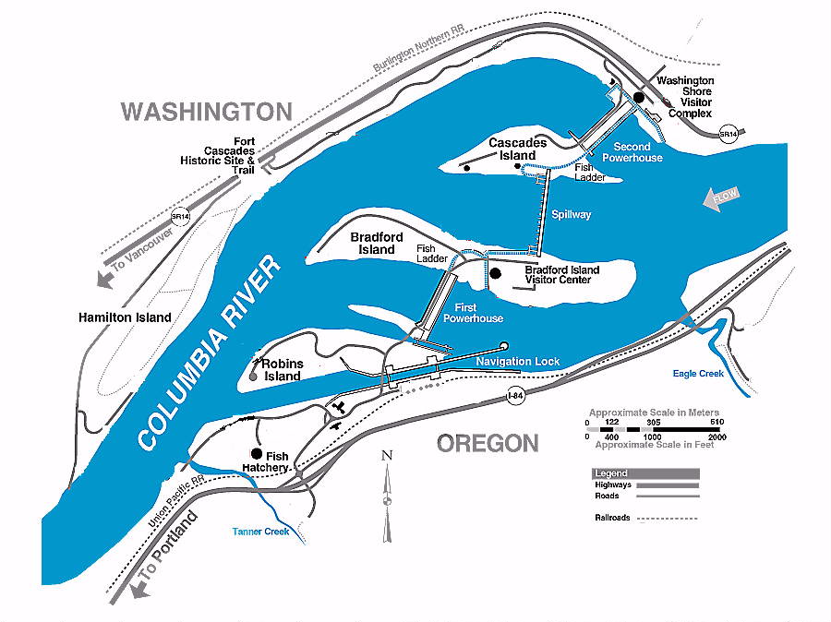

Figure 1 Bonneville Lock & Dam.
The project and fish passage facilities are described in the Fish Passage Plan¹. In summary, the project comprises two powerhouses, a spillway and two navigation locks. The older of the two navigation locks has not operated since early 1993. There are four adult fish ladders for upstream migration, one at PH1, one at the south end of the spillway, one at the north end of the spillway and one at PH2. There are two Juvenile Bypass Systems for downstream migration, one at each powerhouse.
Acronyms and jargon are used freely in this report. The reader can find definitions in the glossary.

FISHWAY OPERATION AND ACTIVITIES
Fish Passage Plan (FPP) Violations

The results of 263 daily fishway inspections (8 of which were conducted by NMFS or FPC) are shown in the following table. The FPP requires seven inspections a week during fish passage season. Project Fisheries conducts two inspections each day and the control room conducts the third. Shown are the FPP violations, numbers of days the violation occurred, and the percentage of days the item was IN criteria.

Auxiliary Water System (AWS) Closures

The AWS’ were closed for trashrack cleaning on several occasions during the 2001-2002 reporting year. Closures ranged from four minutes to over five hours with an average closure lasting 38 minutes. AWS trashracks were usually cleaned once each month with more frequent cleanings during late summer and early fall. This year FV3-9 had 17 closures with an average of 23 minutes per cleaning. FV3-7 had nine closures with average closure time of 41 minutes. FV1-1 was closed 19 times with an average closure lasting 5 minutes. The valve was also shut down during the evening to float debris in late November. Mid season dives and ladder outages are not included in cleaning closure times.
FV4-3, FV4-4, FV5-3 and FV5-4 were occasionally closed for up to 20 hours to facilitate Washington Shore log boom repair, research equipment installation, and mid-season fishway inspection dives.

Fish Unit Outages

03 Dec 01 – 13 Mar 02 F1 OOS for annual maintenance and PH2 ladder dewatering.
20 Mar 02 – 20 Mar 02 F1 OOS for PH2 Collection Channel velocity meter installation.
16 Apr 02 – 16 Apr 02 F1 OOS for trashrack raking.
22 May 02 – 23 May 02 F1 OOS for exciter maintenance and stator measurements.
06 Jun 02 – 06 Jun –02 F1 OOS for cooling water strainer maintenance.
23 Jun 02 – 23 Jun –02 F1 OOS for decontamination of turbine bearing water.
09 Jul 02 – 09 Jul 02 F1 OOS for mid-season fishway inspection and slip ring work.
14 Aug 02 – 15 Aug 02 F1 OOS for contractor measurements and testing.
20 Aug 02 – 20 Aug 02 F1 OOS for T11/12 switching.
18 Sep 02 – 18 Sep 02 F1 OOS to install contractor instrumentation.
01 Nov 02 – present F1 OOS for overhaul and stator rewind

11 Feb 02 – 28 Feb 02 F2 OOS for annual maintenance and PH2 ladder dewatering.
20 Mar 02 – 20 Mar 02 F2 OOS for PH2 Collection Channel velocity meter installation.
16 Apr 02 – 16 Apr 02 F2 OOS for trashrack raking.
09 Jul 02 – 09 Jul 02 F2 OOS for mid-season fishway inspection and slip ring work.
20 Aug 02 – 20 Aug 02 F2 OOS for T11/12 switching.
22 Aug 02 – 22 Aug 02 F2 OOS for T11/12 switching.
01 Oct 02 – 01 Oct 02 F2 OOS for emergency repair of a failed farval line.

Fish units 1 and 2 were placed on standby at other times during the year to “float” trash away from the trash racks. When drawdown measured one foot or greater, fish units were shut down. An adjacent unit was then operated to pull trash away from the fish unit trashracks. This procedure helped prevent debris and silt from accumulating in front of the fish units. Most of the unit outages associated with the floating of trash and debris occurred between midnight and 0300 to minimize impact on adult fish passage.

Fish Facility Outages & Maintenance

29 Nov 01-- 07 Dec 01 AFC&MF (exit) OOS for PIT detector emergency repair.
07 Feb 02 -- 28 Feb 02 AFC&MF OOS for winter maintenance.
10 Dec 01 -- 02 Feb 02 Bradford Island ladder OOS for winter maintenance.
05 Feb 02 -- 08 Mar 02 Cascades Island ladder OOS for winter maintenance.
04 Oct 01 -- 27 Feb 02 DSM1 OOS for water conservation and winter maintenance.
05 Mar 02 -- 06 Mar 02 DSM1 OOS for emergency maintenance.
15 Apr 02 -- 16 Apr 02 DSM1 OOS for emergency maintenance.
23 Apr 02 -- 23 Apr 02 DSM1 OOS for emergency maintenance.
25 Jun 02 -- 25 Jun 02 DSM1 OOS for emergency maintenance.
04 Jul 02 -- 08 Jul 02 DSM1 OOS for emergency maintenance.
18 Jul 02 -- 18 Jul 02 DSM1 OOS for emergency maintenance.
29 Jul 02 -- present DSM1 turned south for summer removal of STS.
15 Jan 02 -- 07 Mar 02 DSM2 OOS for winter maintenance.
03 Dec 01 -- 07 Dec 01 Washington Shore ladder OOS for PIT detector emergency repairs.
11 Feb 02 -- 28 Feb 02 Washington shore ladder OOS for winter maintenance.

Turbine Outages and Dewaterings (outages of at least 24 hours)

Date Out Date Back Unit Reason for Outage
2001 22-Jan-02 3 Turbine rehab
18-Jun-01 14-Nov-02 5 Turbine rehab
19-Nov-01 20-Dec-01 8 Five-year overhaul
03-Dec-01 19-Dec-01 0 Tripped offline
02-Jan-02 08-Apr-02 17 VBS slot modifications
20-Jan-02 21-Jan-02 4 Bank 3 /4 work
28-Jan-02 28-Feb-02 3 Governor rehab
26-Feb-02 21-Mar-02 10 Digital governor installation and five year overhaul
27-Feb-02 04-Mar-02 11 Bearing oil leak
13-Mar-02 14-Mar-02 6 Loop testing with Unit 5
18-Mar-02 18-Apr-02 7 Digital governor/ exciter installation
01-Apr-02 05-Apr-02 3 Governor rehab
08-Apr-02 26-Apr-02 1 Digital governor installation
08-Apr-02 10-Apr-02 15 STS work
10-Apr-02 11-Apr-02 11 STS malfunction
22-Apr-02 16-May-02 8 Digital governor/ exciter installation
23-Apr-02 25-Apr-02 6/7 Relay work
28-Apr-02 29-Apr-02 14 Breaker trouble
06-May-02 06-Jun-02 2 Digital governor/ exciter installation
06-May-02 07-May-02 17 Gantry crane failure
08-May-02 10-May-02 1 Unit 2 governor work
14-May-02 18-Jun-02 15 VBS failure
19-May-02 21-Jun-02 9 Digital governor installation and five year overhaul
21-May-02 23-May-02 1 Pre turbine rehab testing
24-May-02 26-May-02 11 STS failure
10-Jun-02 1 Turbine rehab
17-Jun-02 02-Jul-02 6 Governor modifications
25-Jun-02 27-Jun-02 0 Slip ring cutting
03-Jul-02 22-Jul-02 12 Camera caught on STS frame/exciter failure
08-Jul-02 24-Jul-02 4 Digital governor work
15-Jul-02 17-Jul-02 2 Digital governor work
24-Jul-02 07-Aug-02 7 Vibration inspection
26-Jul-02 30-Jul-02 13 Governor power failure
29-Jul-02 31-Jul-02 6 Bank 5/6 work
29-Jul-02 01-Aug-02 8 Bank 7/8 work/oil cleanup
15-Aug-02 16-Aug-02 0 Bad relay
19-Aug-02 20-Aug-02 10 transducer removal
19-Aug-02 20-Aug-02 11 T11 maintenance
19-Aug-02 20-Aug-02 12-14 T11 maintenance
20-Aug-02 21-Aug-02 11 Exciter trouble
20-Aug-02 22-Aug-02 15-18 T12 maintenance
03-Sep-02 03-Dec-02 9 overhaul
04-Sep-02 12-Sep-02 15 servo motor oil leak
18-Sep-02 19-Sep-02 17 servo motor oil leak
23-Sep-02 03-Dec-02 8 PH1 crane rail work
23-Sep-02 30-Nov-02 10 PH1 crane rail work
30-Sep-02 03-Dec-02 7 PH1 crane rail work
07-Oct-02 16 four year overhaul
08-Nov-02 09-Nov-02 6 Bank 5/6 work

Fish Removal 2001/2002

Fish passage facilities and turbine units are taken out of service and dewatered to allow for inspection, preventative maintenance, repairs, and modifications. As facilities and turbine units are dewatered, project biologists, outside agency personnel, and other project personnel follow procedures outlined in the Fish Passage Plan and detailed in the Fish Recovery Plan to minimize impacts on fish. Adult salmonids are typically released into the forebay above the new navlock. Sturgeon and juvenile salmonids are usually released below the dam at Hamilton Island. The following is a summary of the number of fish that were removed during facility and turbine unit dewaterings. All fish were recovered in good condition unless otherwise noted.

Washington Shore (UMT-TW) and AFF exit ladder (12-03-01): one adult steelhead.

Bradford Island Fishway Junction pool (12-10-01): 16 unclipped adult steelhead, 26 clipped adult steelhead, one clipped adult chinook, one clipped jack chinook, one lamprey, and one unclipped adult Coho, approx. 12 juvenile salmonids and many resident fish.

B-Branch diffuser pools and entrance pool (12-10/11-01): many resident fish and one five foot sturgeon.

A-Branch diffuser pools (12-10-01): nine clipped adult steelhead.

A-Branch entrance pool (01-03-02): two steelhead.

Bradford Island Junction pool (1-03-02): two peamouth, two rainbow trout.

Unit 17 draft tube (1-04-02): one dead juvenile shad and one dead juvenile lamprey.

Unit 3 tail logs (1-15-02): 14 peamouth, whitefish and suckers.

DSM2 and JMF (1-15/16-02): one stickleback.

Cascade Island (2-04-02): four adult steelhead, ten juvenile salmonids, 55 resident chubs, peamouth, and whitefish, eight adult lamprey.

UMT (02-04-02): 41 adult steelhead, couple juvenile salmonids, handful of residents.

Cascade Island diffuser pools (02-05-02): seven adult steelhead, five juvenile salmonids, 20 residents, one adult lamprey.

Washington Shore Ladder (02-11-02): 40 adult steelhead, eight steelhead smolts, 14 adult lamprey, six sculpin.

AFF (02-11-02): 68 live adult steelhead, ten dead adult steelhead (eight clipped, two unclipped), 12 steelhead smolts, six residents, one sculpin, and ten sticklebacks.

UMT (02-11-02): four adult steelhead, three residents, two steelhead smolts.

Washington Shore Ladder (02-21-02): two adult lamprey.

Cascade Island Ladder (2-26-02): 24 peamouth from behind contractor sandbags.

Unit 17 Tail logs (04-08-02): one crayfish, ten sculpin and one catfish.

DSM1 (04-15-02): two adult spring chinook, four steelhead smolts, two chinook smolts.

DSM1 (4-23-02): one adult spring chinook, one adult steelhead, 14 juvenile steelhead, ten juvenile chinook.

Unit 9 Draft Tube (5-21-02): one juvenile salmonid and one dead sturgeon.

DSM1 (6-7-02): two sturgeon, 20 juvenile steelhead, five live juvenile chinook and 5 dead juvenile chinook.

Unit 1 Draft Tube (6-11-02): three sturgeon and 45-50 adult lamprey.

Unit 9 Tail logs (6-19-02): four sturgeon, two crawfish, two sticklebacks, two adult lamprey, and 12-15 sculpin.

DSM 1 (7-8-02): three sub-yearling Chinook, two sculpin. Dead fish on the inclined screen.

Unit 9 draft tube (9-3-02): two sturgeon and one lamprey.

Unit 9 tail logs (10-01-02): 19 sculpin.

Unit 16 Draft Tube (10-08-02): 12 sturgeon, three channel catfish, one sculpin, one sucker.

Fish Unit 1 Draft Tube (11-01-02): one sculpin, five dead juvenile shad.

Unit 5 Tail logs (11-05-02): 44 crayfish, 69 sculpin, one smallmouth bass, one sturgeon, one stickleback, one bluegill.

Adult Fish Facility entrance ladder (11-25-02): six unknown steelhead, one unclipped steelhead, three clipped steelhead, 15 coho, two shad, two suckers, three whitefish.

Adult Fish Facility exit ladder (11-25-02): two steelhead, one sucker, four whitefish.

VBS/STS Inspections

The Fish Passage Plan requires STS inspections be conducted monthly, and VBS inspections once every two months. Because each STS has a timer that automatically shows elapsed time of operation, STS inspection frequency can be measured by run time. The equivalent of one month of continuous operating time is 720 hours. Bonneville inspects both STS and VBS with an underwater video camera. Video allows STSs and VBSs to be inspected simultaneously, and eliminates the need to dip gatewells and handle fish.

Table 1. Submersible Traveling Screen (STS) and Vertical Barrier Screen (VBS) Inspections 2001-2002

Zebra Mussels

Through weekly inspections of the monitoring station at the First Powerhouse and of all dewatered fishways, we have found no indication of zebra mussel colonization. It is understood that their arrival is inevitable. We continue monitoring with hopes that control programs can be initiated at the first indication of the zebra mussel’s arrival in the Pacific Northwest.

GLOSSARY
AFC&MF Adult Fish Collection and Monitoring Facility. Lab associated with the Washington Shore ladder. Adult fish are trapped for research purposes.
AFF----------------Adult Fish Facility. Also known as the AFC&MF.
BiOp Biological Opinion.
BON Bonneville Lock & Dam.
Downwell Opening through which water and fish drop after excess water is drawn away through a dewatering screen. Start of the transport conduit for fish from DSM1 to the tailrace.
DSM 1 Downstream Migrant transportation channel (PH1). Transport channel for juvenile fish from gatewell orifices to the downwell.
DSM 2------------Downstream Migrant transportation channel (PH2). Transport channel for juvenile fish from gatewell orifices to the juvenile transport pipe.
CRITFC Columbia River Intertribal Fish Commission.
FFU Fisheries Field Unit. Unit in the Corps of Engineers’ Portland District Construction, Operations Division that conducts fish related evaluations and monitoring.
FGE Fish Guidance Efficiency. Proportion of fish entering turbine intakes that are guided into the juvenile bypass system.
Forebay That area of a reservoir immediately upstream of a dam.
FPC Fish Passage Center.
FPE Fish Passage Efficiency. Proportion of juvenile fish that pass the dam by non-turbine routes.
FPP Fish Passage Plan.
JBS Juvenile Fish Bypass System. Usually refers to PH2.
JMF Juvenile Fish Monitoring Facility. Lab associated with the PH2 JBS.
Kcfs Thousand cubic feet per second.
NDE North Downstream Entrance. Refers to one of the four large overflow weir adult fishway entrances at PH2.
NUE North Upstream Entrance. See NDE.
NMFS National Marine Fisheries Service.
ODFW Oregon Department of Fish & Wildlife
OOS Out Of Service.
PCC Powerhouse Collection Channel. Part of the adult fishway spanning the length of the downstream side of each powerhouse.
PH1 Bonneville First Powerhouse.
PH2 Bonneville Second Powerhouse.
PIT-----------------Passive Integrated Transponder. A tag inserted into juvenile and adult fish. Detectors are installed at all fish passage systems.
Project Bonneville Lock & Dam.
SDE South Downstream Entrance. See NDE.
SUE South Upstream Entrance. See NDE.
STS Submersible Traveling Screen.
Tailwater The portion of a river immediately downstream of a dam or powerhouse.
TIE Turbine Intake Extension.
Tule Early spawning fall chinook.
UMT Upstream Migrant Transportation channel. This channel connects Cascades Island ladder to Washington Shore ladder through PH2.
VBS Vertical Barrier Screen.
WDFW Washington Department of Fish & Wildlife.

REFERENCES ? _____. 2002. Fish Passage Plan for Corps of Engineers Projects. U. S. Army Corps of Engineers, North Pacific Division, Portland, Oregon.

